**PASTRY AREA**

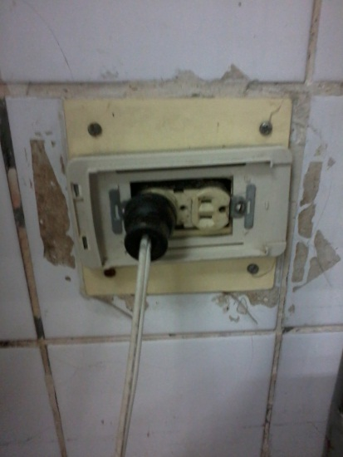

**NEAR S/S WORKING TABLE**

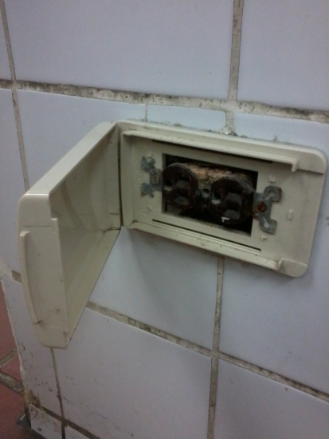

**NEAR WALL TILES POST**